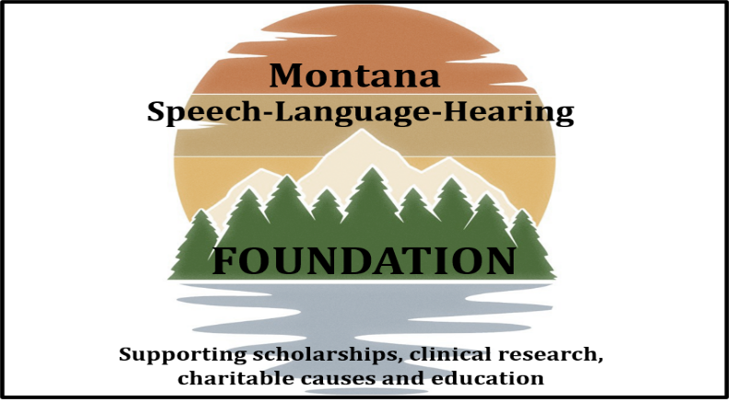
MSHA STUDENT SCHOLARSHIP APPLICATION
The Montana Speech Language & Hearing Foundation believes strongly in supporting graduate students committed to serving the people of Montana. We are pleased to offer this scholarship award in the amount of $1000 for the 2022-2023 school year to two students working toward a Master’s degree.

Current Date
Full Name
Address
Phone
Email
Current undergraduate or graduate program |  | Expected Master’s program completion date:
Cumulative undergrad GPA |  | Cumulative graduate GPA
Length of time you have been a Montana resident:
Educational background, including high school, undergraduate, and graduate, as appropriate. | High School Name Location Dates Attended Degree Earned  Undergrad Institution Location Dates Attended Degree Earned  Graduate Institution Location Dates Attended Degree Earned  Other Location Dates Attended Degree Earned
Describe any work you have done to help MSHA and/or the Montana community during your time as a student or working professional. | Student member of MSHA? Yes No
Briefly list any additional life experiences you would like the committee to consider.

In addition to this application form, please submit:

- An essay (two pages maximum) in which you respond to two of the following prompts:
- What unique characteristics attract you to clinical practice in a rural state such as MT?

- What changes do you anticipate our field might experience in the next 20 years?

- What does it mean to be a good communicator and why is this critical to success in our profession?

- Describe an experience you had communicating with someone who has a communication disorder and how it shaped your desire to continue in this field.

- Unofficial transcripts of all college and university work;

- Current Resume or Curriculum Vitae

- Two letters of support specific to your scholarship/fellowship request(s):
No more than one letter can be from a faculty member in the School of Speech, Language, Hearing, and Occupational Sciences (SLHOS) at the University of Montana.

Deadline for all applications is: Thursday, September 15, 2022

Recipients will be contacted by email and awards will be presented in October at the annual MSHA business meeting.

Please submit the following materials one of two ways:
____ Application (2 pages) ____ Essays ____ Transcripts ____Resume/CV
____ Letters of support

1) Scan in and submit digitally via email to: barbara.doughty74@gmail.com
Please use subject line: MSHA Foundation Scholarship Application

2) Mail to: MSHA Foundation Scholarship Committee
c/o Barbara Doughty
3300 3rd Street NE
Great Falls, MT 59404

Signature:___________________________________ Date:_______________________

